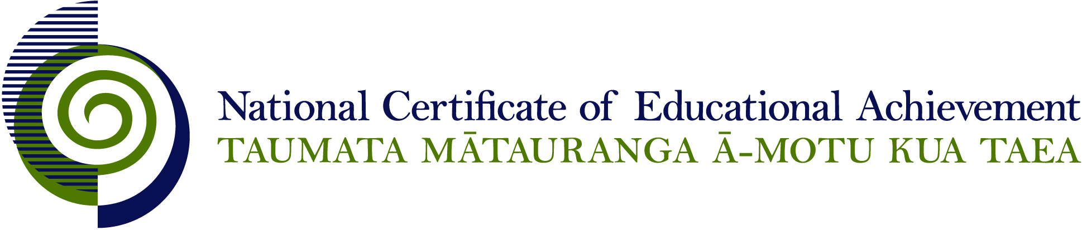

NCEA Level 2 Art History

Conditions of Assessment

General Information

Subject Reference | Art History
Domain | Art History
Level | 2

Conditions of Assessment

These Conditions provide guidelines for assessment against internally assessed Achievement Standards. Guidance is provided on:
- specific requirements for all assessments against this Standard
- appropriate ways of, and conditions for, gathering evidence
- ensuring that evidence is authentic.

Assessors must be familiar with guidance on assessment practice in learning centres, including enforcing timeframes and deadlines. The NZQA website offers resources that would be useful to read in conjunction with these Conditions of Assessment.

The learning centre’s Assessment Policy and Conditions of Assessment must be consistent with NZQA’s Assessment Rules for Schools with Consent to Assess. This link includes guidance for managing internal moderation and the collection of evidence.

Gathering Evidence

Internal assessment provides considerable flexibility in the collection of evidence. Evidence can be collected in different ways to suit a range of teaching and learning styles, and a range of contexts of teaching and learning. Care needs to be taken to allow students opportunities to present their best evidence against the Standard(s) that are free from unnecessary constraints.

It is recommended that the design of assessment reflects and reinforces the ways students have been learning. Collection of evidence for the internally assessed Standards could include, but is not restricted to, an extended task, an investigation, digital evidence (such as recorded interviews, blogs, photographs, or film), or a portfolio of evidence.

Effective assessment should suit the nature of the learning being assessed, provide opportunities to meet the diverse needs of all students, and be valid and fair.

Ensuring Authenticity of Evidence

Authenticity of student evidence needs to be assured regardless of the method of collecting evidence. This must be in line with the learning centre’s policy and NZQA’s Assessment Rules for Schools with Consent to Assess.

Ensure that the student’s evidence is individually identifiable and represents the student’s own work. The evidence must be an accurate reflection of what the student independently knows and can do, according to the Standard being assessed. This includes evidence submitted as part of a group assessment, evidence produced outside of class time or without assessor supervision, and evidence produced with any use of generative artificial intelligence tools (GenAI). GenAI use should be carefully considered in the context of the Standard being assessed and its Conditions of Assessment, discussed with students before the assessment, and its use must be acknowledged. For example, an investigation carried out over several sessions could include:
- teacher guidance on the nature and extent of acceptable GenAI use, if any
- assessor observations and conversations
- meeting with the student at set milestones or checkpoints
- the student’s record of progress, such as photographic entries or any GenAI prompts used.

Specific Information for Individual Internal Achievement Standards

Achievement Standard Number | 91183 Art History 2.4
Title | Examine how media are used to create effects in art works
Number of Credits | 4
Version | 2

Art works may be selected by teacher or student.

Evidence may be presented by the student in a range of forms, including:
- oral presentations
- written paragraphs
- annotated charts, drawings or posters
- digital presentations
- practical investigations.

Students need to retain their focus on how media are used to create effects in art works. Effects that are unrelated to media, for example the artist’s selection of subject matter, are not assessed in this standard.

It is recommended that a minimum of three works should be examined so that there is sufficient evidence on which to make a judgement against the standard.

It is also recommended that students be given the opportunity to examine actual art works.

Although group activities may be used to examine how media are used in art works, the evidence provided for assessment must be completed by individual students.

Teachers may guide students through the examination process however this guidance should not compromise authenticity.

Where manageable, one further assessment opportunity may be made available for all students.

Achievement Standard Number | 91184 Art History 2.5
Title | Communicate understanding of an art history topic
Number of Credits | 4
Version | 2

The assessor may direct and assist the activity by:
- providing a topic for students
- providing some of the sources
- suggesting focussing questions

Evidence may be presented by the student in a range of forms, including:
- oral presentations
- written paragraphs, article or essay
- annotated charts, drawings or posters
- digital presentations

This is an in-class and homework task, to be completed by individual students. Teachers, however, must closely supervise the activity in order to ensure authenticity.

Where manageable, one further assessment opportunity may be made available for all students.

Achievement Standard Number | 91185 Art History 2.6
Title | Communicate a considered personal response to art works
Number of Credits | 4
Version | 2

For this assessment, students should have the opportunity to examine actual art works. Art works may be viewed in exhibitions, school or personal collections, public places etc. Art works may be selected by the teacher or students.

Evidence may be presented by the student in a range of forms, including:
- journal or blog entries
- oral presentations
- written paragraphs
- written or recorded interview
- annotated charts, drawings or posters
- digital presentations.

Although group activities may be used to view art works, personal responses must be completed by individual students.

This is an in-class and homework task, to be completed by individual students. Teachers may guide students through the assessment process however this guidance should not compromise authenticity.

For the purposes of assessment a minimum of three works should be interpreted and responded to.

Where manageable, one further assessment opportunity may be made available for all students.

Achievement Standard Number | 91186 Art History 2.7
Title | Demonstrate understanding of art works in relation to their physical environments
Number of Credits | 4
Version | 2

For this activity, students are required to examine art works in their physical environments. Art works may be selected by the teacher or students.

Evidence may be presented by the student in a range of forms, including:
- oral presentations
- written paragraphs
- written or recorded interview
- annotated charts, drawings or posters
- digital presentations.

This is an in-class and homework task, to be completed by individual students. Teachers may guide students through the assessment process however this guidance should not compromise authenticity.

Although group activities may be used to view art works and gather information, the evidence provided for assessment should be completed by individual students.

For the purposes of assessment a minimum of three works should be considered.

Where manageable, one further assessment opportunity may be made available for all students.

